Department of Computer Science and Engineering
Assignment Questions
Course Code & Name : MLA03-Reinforcement Learning
Assignment Title: | Develop a multi-agent reinforcement learning framework that combines policy-based and model-based RL for traffic optimization. Explain how hierarchical learning and meta-learning can be incorporated to improve coordination, planning, and adaptation to unexpected traffic conditions.
Course Outcome(s) – CO: | CO1: Implement policy-based reinforcement learning methods to develop efficient solutions for complex environments.  CO2: Evaluate model-based reinforcement learning approaches for prediction, planning, and policy optimization.  CO3: Apply hierarchical, meta-learning, and multi-agent RL approaches to solve complex decision-making problems
Bloom’s Taxonomy Level | L3 – Apply; L4 – Analyse
SDG Mapping (SDG 1-17) | SDG 7 – Affordable and Clean Energy;  SDG 11 – Sustainable Cities and Communities;  SDG 12 – Responsible Consumption and Production
Problem Statement : Design, implement, and evaluate a menu-driven, object-oriented C++ application to manage a Smart EV Charging Facility for a large University campus, where a limited number of charging points operate under a fixed power capacity and manual coordination has become unreliable. The prototype shall automate the charging workflow — registering vehicles, allocating charging points, creating and updating sessions, recording energy consumed, computing cost by peak/off-peak tariff, comparing sessions, and generating a station-utilization report. The core entities (vehicles, charging points, sessions) shall be modelled as encapsulated classes with suitable data members, member functions, and control structures . Different vehicle or charger types shall be organized through an inheritance hierarchy with polymorphism (virtual functions), so charging behaviour, tariff computation, and session comparison adapt at run time . Robustness shall be ensured through constructors (default, parameterized, copy), destructors that finalize sessions and release points, and at least two meaningful operator overloads — e.g., to compare sessions and format report output .

1. Introduction and Problem Statement
Urban traffic networks are dynamic environments in which vehicle demand changes continuously. Fixed-time traffic signals use predetermined timings and therefore cannot react efficiently to changing queues, peak-hour demand, accidents, road closures, rainfall or sudden traffic surges. These limitations increase waiting time, congestion, fuel consumption and emissions.
The proposed system develops a Multi-Agent Reinforcement Learning (MARL) framework for intelligent traffic optimization. Each traffic intersection is modeled as an intelligent agent. The agent observes local traffic conditions, communicates relevant information with neighboring agents and selects signal-control actions. Policy-based reinforcement learning learns decision policies, while model-based reinforcement learning predicts future traffic states and supports planning.
Hierarchical learning is introduced to divide decisions into local, regional and global levels. Meta-learning is incorporated so that the system can adapt rapidly to unexpected traffic conditions without relearning everything from the beginning.
Objectives
Develop a MARL framework for adaptive traffic signal control.
Minimize waiting time and queue length.
Improve coordination among neighboring intersections.
Use policy-based RL for signal decisions.
Use model-based RL for prediction and planning.
Apply hierarchical learning for scalable coordination.
Apply meta-learning for rapid adaptation.
Implement core concepts using object-oriented C++.
Evaluate performance using traffic-related metrics.
Relate the system to SDG 7, SDG 11 and SDG 12.
2. Overall System Architecture
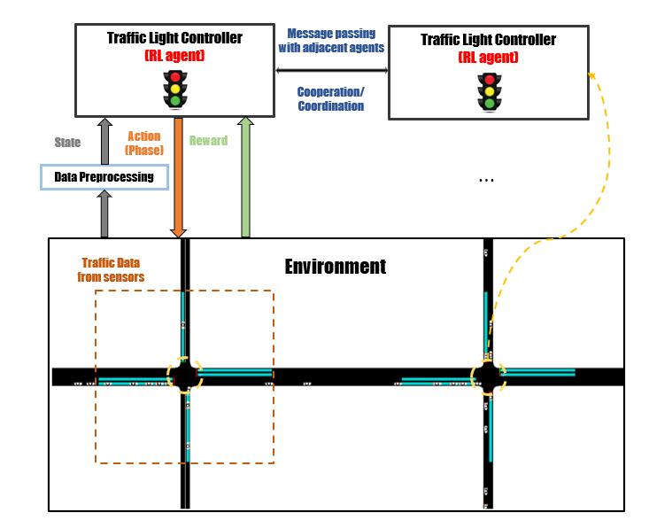
Figure 1. Overall architecture of the proposed traffic optimization framework.
The traffic environment provides vehicle and road information to multiple intersection agents. Each agent observes its state and participates in the decision process. The policy-based component selects actions, while the model-based component predicts future conditions and evaluates alternatives. Hierarchical coordination manages local and regional decisions, and meta-learning enables rapid adaptation when the environment changes.
Core Data Flow
Stage | Function
Environment | Provides vehicle flow, queues, density and signal information.
Observation | Agents collect local and neighboring traffic states.
Decision | Policy-based RL chooses signal actions.
Prediction | Model-based RL predicts possible future states.
Coordination | Agents share information and coordinate signal timing.
Adaptation | Meta-learning updates behavior for new conditions.
Outcome | Reduced delay, queues and congestion with improved flow.
3. Traffic RL Formulation and OOP Design
3.1 State, Action and Reward
Element | Representation
State | Vehicle count, queue length, waiting time, density and signal phase.
Action | Increase green time, decrease green time, change phase or maintain phase.
Reward | R = −(Waiting Time + Queue Length).
Agent | Intelligent traffic signal controller.
Environment | Road network or traffic simulator.
The reward is designed so that lower delay and shorter queues produce better rewards. The formulation can be extended with throughput, fuel consumption and emissions.
3.2 C++ Class Design
Class | Responsibility
TrafficState | Stores current traffic conditions.
TrafficAgent | Base class containing state, action and reward.
LocalAgent | Controls an individual intersection.
RegionalAgent | Coordinates several intersections.
TrafficIntersection | Represents an intersection and its status.
TrafficPolicy | Represents policy-related decision logic.
TrafficModel | Represents predicted state transitions.
OOP Concepts
Encapsulation protects traffic state and agent data.
Inheritance creates specialized local and regional agents.
Virtual functions provide runtime polymorphism.
Static members can track total agents/intersections.
Constructors initialize objects and copy constructors support object copying.
Destructors release dynamically allocated agents.
Operator overloading can compare agents by reward.
4. CO1 – Policy-Based Reinforcement Learning
CO1: Implement policy-based reinforcement learning methods to develop efficient solutions for complex environments.
Policy-based reinforcement learning directly learns a policy π(a|s), which represents the probability or preference of selecting action a when the system is in state s. In traffic optimization, the policy maps traffic conditions to signal decisions. The policy can learn that a heavily congested approach requires a longer green phase, while a lightly loaded approach can receive a shorter phase.

Figure 2. CO1 architecture – policy-based traffic signal control.
CO1 State–Action–Reward Table
Component | Traffic Application
State | Queue, vehicle count, density, waiting time and signal phase.
Policy | Mapping from traffic state to signal-control action.
Action | Extend, reduce, switch or maintain a signal phase.
Reward | Negative delay and queue length.
Learning Goal | Maximize cumulative reward by reducing congestion.
CO1 Working
Observe the current intersection state.
Use the learned policy to select a signal action.
Apply the signal action to the traffic environment.
Observe the new traffic state.
Calculate the reward.
Update the policy.
Repeat until the policy becomes effective.
5. CO1 – Algorithm, Pseudocode and C++ Mapping
CO1 Algorithm
1. Initialize the traffic environment and policy. 2. Observe the current state. 3. Select an action using the policy. 4. Apply the action. 5. Observe the new state. 6. Calculate reward. 7. Update policy parameters. 8. Repeat for the required training episodes. 9. Use the trained policy for traffic control.
CO1 Pseudocode
START
Initialize traffic environment
Initialize policy π
FOR each training step
Observe current traffic state S
Select action A using policy π(A|S)
Apply action A to traffic signal
Observe next state S'
Calculate reward R = -(delay + queue)
Update policy using observed reward
END FOR
Deploy learned policy
STOP
C++ Object-Oriented Mapping
OOP Feature | CO1 Usage
Class | TrafficAgent represents the controller.
Encapsulation | State, reward and action are protected/private.
Inheritance | LocalAgent specializes TrafficAgent.
Polymorphism | selectAction() is virtual.
Static Member | Tracks number of agents.
Operator Overload | Compares agent rewards using >.
CO1 Analysis
Policy-based RL is suitable when the system must repeatedly choose signal actions in response to changing traffic states. Its main advantage is direct decision-making. Its effectiveness depends on the quality of the state representation, reward function and training process.
6. CO1 – Implementation and Results
Sample Implementation Logic
virtual void selectAction();
if (queueLength > 20)
action = INCREASE_GREEN;
else if (queueLength > 10)
action = CHANGE_PHASE;
else
action = MAINTAIN_PHASE;
reward = -(waitingTime + queueLength);
Illustrative Result
Control Method | Average Waiting Time | Interpretation
Fixed-Time Signal | 80 units | Higher delay under changing traffic.
Policy-Based RL | 45 units | Lower delay after policy optimization.
The values above are illustrative for demonstrating the expected result format. Actual values must be replaced with measurements obtained from the final simulation.
CO1 Result Analysis
A learned policy can react to current traffic instead of following a fixed schedule.
High queues receive greater signal priority.
The reward guides the policy toward lower congestion.
Performance should be evaluated over multiple traffic scenarios.
The final report should compare baseline and learned-policy performance.
CO1 Expected Outcome
The expected outcome is reduced average waiting time and queue length, with improved throughput compared with a fixed-time signal controller.
7. CO2 – Model-Based Reinforcement Learning
CO2: Evaluate model-based reinforcement learning approaches for prediction, planning, and policy optimization.
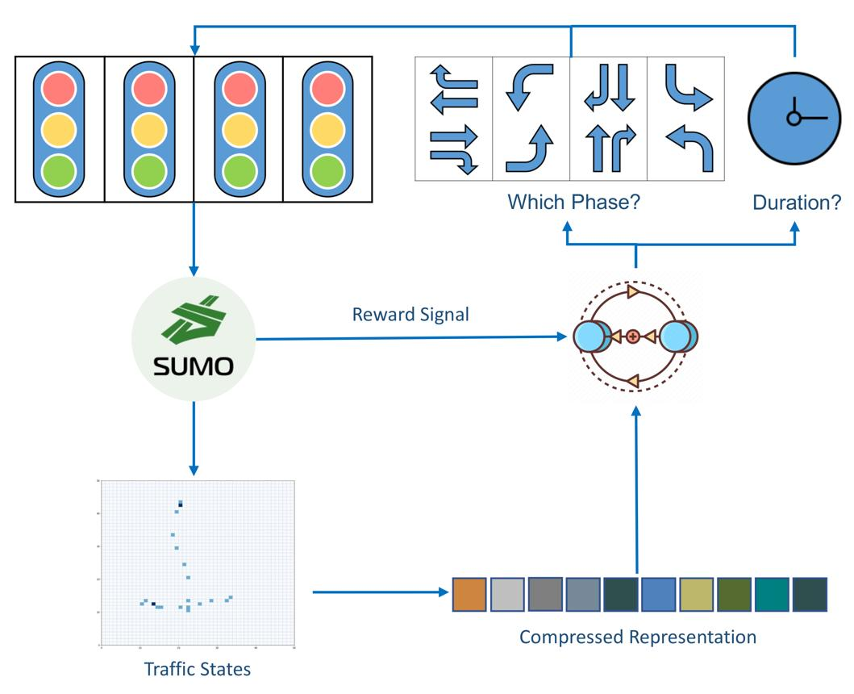
Model-based reinforcement learning maintains a model of how traffic states change after actions. Instead of only learning what action works, the agent can predict what may happen after candidate actions. This supports planning before a signal decision is executed.

Figure 3. CO2 architecture – model-based prediction and planning.
CO2 Components
Component | Purpose
Current State | Represents current traffic conditions.
Traffic Model | Approximates state transitions after actions.
Prediction | Estimates future queue, delay and density.
Planning | Evaluates alternative signal actions.
Policy Optimization | Uses predicted outcomes to improve decisions.
Example
If a northbound approach has a rapidly growing queue, the traffic model can predict the queue under different green-time choices. The planner compares those predicted outcomes and selects the action with the best expected reward.
8. CO2 – Algorithm, Pseudocode and Planning
CO2 Algorithm
1. Initialize a traffic transition model. 2. Observe the current state. 3. Generate possible signal actions. 4. Predict the next state for each action. 5. Estimate reward/cost for each predicted state. 6. Select the action with the best expected outcome. 7. Execute the action. 8. Compare predicted and actual results. 9. Update the model.
CO2 Pseudocode
START
Initialize traffic model M
Observe current state S
Generate possible actions A1...An
FOR each action A
Predict next state S' using M
Estimate expected reward
END FOR
Select action with best expected reward
Execute selected action
Observe actual next state
Update traffic model
Repeat
STOP
Planning Table
Candidate Action | Predicted Queue | Decision
Increase green | Low | Preferred when demand is high
Decrease green | High | Avoid under heavy demand
Change phase | Medium | Useful when another approach is congested
Maintain | Medium/Low | Useful under stable traffic
CO2 Analysis
Model-based RL adds planning capability because the agent can reason about possible future states before committing to an action. The trade-off is computational cost and the need for a sufficiently accurate traffic model.
9. CO2 – Implementation and Results
Sample C++ Model Logic
double predictQueue(int queue, int action)
{
if (action == 1) return queue * 0.70;
if (action == 2) return queue * 1.15;
if (action == 3) return queue * 0.85;
return queue;
}
Illustrative Planning Output
Action | Predicted Queue | Predicted Quality
Increase Green | 14 | High
Decrease Green | 23 | Low
Change Phase | 17 | Medium
Maintain | 20 | Medium-Low
Based on the illustrative prediction, increasing green time gives the lowest predicted queue and is selected. In an actual experiment, predictions should come from the trained traffic model and be compared with observed traffic.
CO2 Result Analysis
Prediction allows the agent to evaluate future consequences.
Planning can reduce myopic decisions.
The model can be updated when prediction errors are observed.
Model quality strongly affects decision quality.
Model-based planning can complement policy-based decision-making.
10. CO3 – Multi-Agent Reinforcement Learning
CO3: Apply hierarchical, meta-learning, and multi-agent RL approaches to solve complex decision-making problems.
In a traffic network, each intersection can be treated as an independent learning agent. A single agent controls one junction, observes local conditions and communicates selected information to neighboring agents. Multi-agent learning is important because decisions at one intersection affect traffic arriving at another intersection.
Agent Coordination
Agent Information | Purpose
Queue Length | Shows congestion level at an intersection.
Traffic Density | Indicates road occupancy.
Signal Phase | Helps neighbors anticipate traffic movement.
Waiting Time | Supports priority decisions.
Predicted Flow | Supports coordination and route progression.
For example, when Intersection A releases a large traffic queue toward Intersection B, B can anticipate the incoming flow and adjust its signal timing. This creates coordinated rather than isolated signal control.
CO3 Multi-Agent Flow
Local observation → agent decision → information sharing → neighboring coordination → network-level outcome.
11. CO3 – Hierarchical Learning
Hierarchical learning divides a complex traffic-control problem into levels. A higher-level manager sets regional objectives, while lower-level worker agents control individual intersections. This reduces the decision complexity for each local agent.
Hierarchy
Level | Responsibility
Global | Monitors overall network objectives such as throughput and congestion.
Regional | Coordinates several nearby intersections.
Local | Controls the signal at an individual intersection.
Benefits
Scales better to large traffic networks.
Separates strategic planning from local signal control.
Allows local agents to react quickly to immediate conditions.
Regional coordination can improve traffic progression.
Global objectives prevent agents from optimizing only their own intersection.
Example
A regional controller may identify a major traffic corridor and request coordinated green phases. Local agents then adjust their own signals while respecting local queue conditions.
12. CO3 – Meta-Learning and Unexpected Conditions
Meta-learning focuses on learning how to adapt. In traffic optimization, the system may encounter conditions that were not common during training. Examples include accidents, road construction, heavy rain, event traffic, road closures and sudden demand surges.
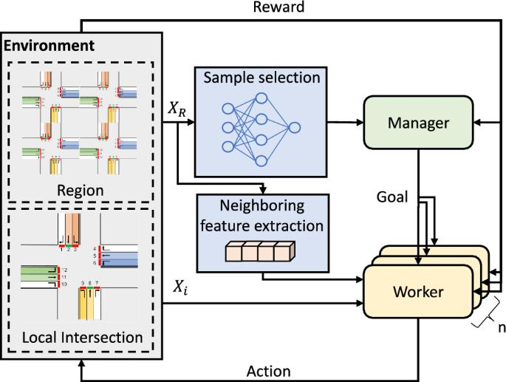
Figure 4. CO3 architecture – hierarchical MARL and meta-learning adaptation.
Adaptation Process
Normal traffic → learned knowledge → unexpected condition → detect distribution change → meta-learning adaptation → updated policy → improved traffic control.
Unexpected Condition Table
Condition | Possible Adaptation
Accident | Reduce priority for blocked approach and redirect flow.
Road Closure | Coordinate neighboring signals for alternate routes.
Heavy Rain | Adapt signal timing to changed speed and flow.
Traffic Surge | Increase capacity for overloaded approaches.
Large Event | Use regional coordination for temporary demand patterns.
CO3 Analysis
Meta-learning can reduce the amount of new experience needed when traffic conditions change. Combined with hierarchical coordination and multi-agent learning, it provides a scalable approach to dynamic traffic networks.
13. Integrated Evaluation, SDG Mapping and Reflection
Performance Evaluation
Metric | Desired Direction | Purpose
Average Waiting Time | Decrease | Measures vehicle delay.
Queue Length | Decrease | Measures congestion.
Traffic Density | Balanced | Measures road occupancy.
Throughput | Increase | Measures vehicles processed.
Average Reward | Increase | Measures decision quality.
Fuel/energy use | Decrease | Measures efficiency.
Emissions | Decrease | Measures environmental impact.
SDG Mapping
SDG | Relevance
SDG 7 – Affordable and Clean Energy | Reduced idling and smoother traffic can lower unnecessary fuel/energy consumption.
SDG 11 – Sustainable Cities and Communities | Intelligent traffic control supports efficient and sustainable transportation.
SDG 12 – Responsible Consumption and Production | Improved traffic flow reduces unnecessary resource consumption.
Reflection
The project demonstrates how C++ object-oriented programming can provide a structured foundation for an intelligent traffic-control framework. Encapsulation separates traffic data from operations, while inheritance and virtual functions allow different agent types to implement different decision strategies. Policy-based RL provides direct signal decisions, model-based RL provides prediction and planning, and multi-agent learning enables coordination. Hierarchical learning addresses scalability, while meta-learning supports adaptation to unexpected situations.
14. Conclusion, Future Scope and Deliverables
Conclusion
The proposed Multi-Agent Reinforcement Learning framework combines policy-based RL, model-based RL, multi-agent coordination, hierarchical learning and meta-learning for intelligent traffic optimization. The approach allows traffic intersections to learn adaptive signal decisions, predict future conditions, coordinate with neighboring agents and respond to unexpected events. The C++ object-oriented design provides classes, inheritance, polymorphism, constructors, destructors, static members and operator overloading suitable for the DSA01 course.
Future Scope
Integrate real-time IoT traffic sensors.
Use camera-based vehicle detection.
Connect the system with a traffic simulator such as SUMO.
Use deep reinforcement learning for large state spaces.
Implement dynamic route recommendation.
Integrate weather and accident feeds.
Use cloud-based multi-intersection coordination.
Add real-time dashboards and historical analytics.
Deliverables
Deliverable | Contents
Pseudocode | Overall and CO-wise algorithms.
Implementation & Results | C++ source code, sample outputs and measured performance.
Architecture Diagrams | Overall architecture and separate CO1, CO2 and CO3 diagrams.
GitHub Upload | Source code, README, pseudocode and output screenshots.
Final Expected Result
The system is expected to reduce waiting time and queue length, improve throughput and provide better adaptation to changing traffic conditions. Actual numerical results should be generated by the implemented simulation and reported without replacing them with illustrative values.
References / Research Basis
1. Research literature on multi-agent reinforcement learning for traffic signal control.
2. Research literature on model-based reinforcement learning for traffic signal planning.
3. Research literature on hierarchical reinforcement learning for traffic control.
4. Research literature on meta-learning for traffic signal adaptation.
Note: The diagrams in this assignment are original explanatory diagrams prepared for this report; they are not copied figures from a research paper.

Assessment Rubrics

Criteria (CO Mapping) | Max Marks | Excellent | Good | Satisfactory | Needs Improvement
Requirement Understanding, Data Types, Operators & Control Structures  (CO1) | 10 | Correctly identifies all entities and workflow from the problem statement; data types, operators, and control structures used efficiently and correctly throughout. | Identifies most entities/workflow with minor gaps; mostly correct use of data types, operators, and control structures. | Basic entities/workflow identified; data types and control structures used but with some inefficiencies or errors. | Requirements misunderstood; frequent misuse of data types/operators/control flow affecting correctness.
Class Design: Encapsulation, Access Specifiers & Member Functions  (CO2) | 15 | Classes for Vehicle, ChargingPoint, and Session are well encapsulated with appropriate access specifiers; member functions are cohesive and correctly scoped. | Reasonable encapsulation with minor access-specifier misuse. | Classes exist but encapsulation is weak (e.g., excessive public members). | Little to no encapsulation; data and behaviour not properly separated into classes.
Static Members & Arrays of Objects  (CO2) | 10 | Static members correctly used for shared/station-level data; arrays/collections of objects correctly manage multiple vehicles/sessions. | Static members and object arrays used with minor logical errors. | Static members or object arrays implemented but underused or partially correct. | Static members and/or arrays of objects missing or non-functional.
Inheritance Hierarchy & Polymorphism (Virtual Functions)  (CO2/CO3) | 15 | Clear inheritance hierarchy for vehicle/charger types; virtual functions correctly enable run-time adaptation of charging behaviour, tariff computation, and session comparison. | Inheritance and virtual functions are implemented correctly but adaptation logic is limited to one or two behaviours. | Basic inheritance present but shallow; virtual functions declared but overriding are incomplete or inconsistent. | No meaningful inheritance hierarchy or polymorphism implemented.
Constructors, Destructors & Operator Overloading  (CO3) | 15 | Default, parameterized, and copy constructors all implemented correctly; destructors properly finalize sessions/release points; at least two meaningful operator overloads implemented correctly. | Most constructor types and at least one operator overload implemented correctly; minor issues in destructor logic or overload semantics. | Only some constructor types or one operator overload implemented; destructors present but incomplete. | Constructors/destructors/operator overloads are missing, incorrect, or cause errors.
Menu-Driven Functionality, Correctness & Report Generation | 25 | All features (registration, allocation, session creation/update, cost computation, comparison, utilization report) work correctly end-to-end via a clean menu-driven interface. | Most features work correctly; minor bugs in edge cases or report formatting. | Core features work but some functionality (e.g., report or tariff calculation) is incomplete or buggy. | Program does not run reliably or major features are missing/non-functional.
Reflection: Design Decisions, SDG Relevance & Learning Outcomes | 10 | Thoughtful justification of design choices, clear connection to SDG 7/11/12 relevance, and honest, specific account of challenges faced and learning gained. | General justification of design choices; sustainability connection and challenges mentioned but lack depth. | Reflection present but generic; limited justification of design or vague account of learning outcomes. | No genuine reflection submitted, or content is generic with no real design/SDG/learning connection.
Deliverables
To receive full credit, each submission must include the following deliverables:
- Pseudo code
- Implementation & Results
- Github Upload

